DSA1604- KNOWNLEDGE ENGNEERTING AND DATA SCIENCE
LAB EXPERIMENTS

Experiment 1: Knowledge Representation Using Python
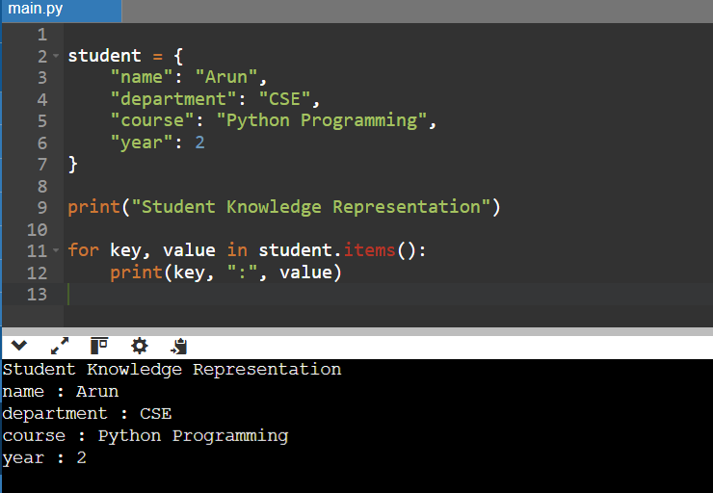

Experiment 2: Knowledge Acquisition
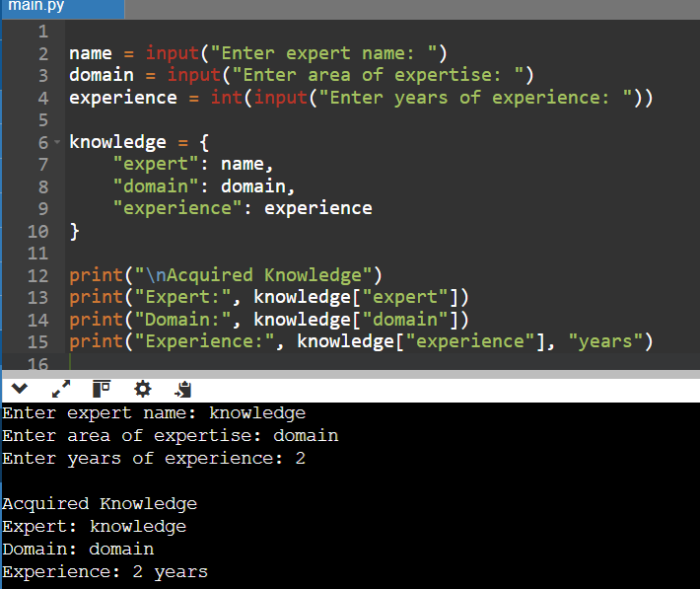

Experiment 3: Knowledge-Based Course Recommendation System
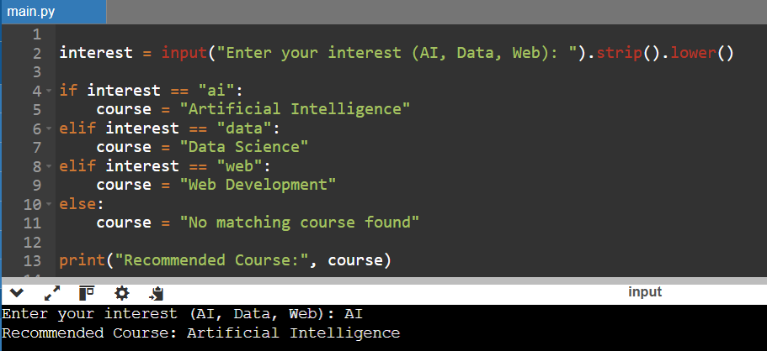

Experiment 4: Rule-Based Expert System for Network Troubleshooting
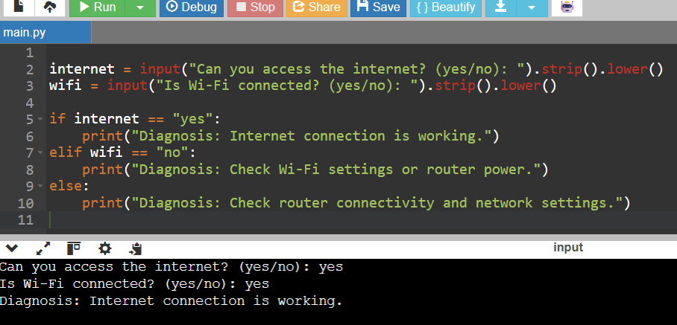

Experiment 5: Semantic Network Using NetworkX
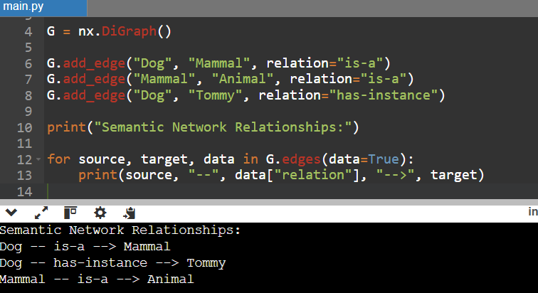

Experiment 6: Frame-Based Knowledge Representation
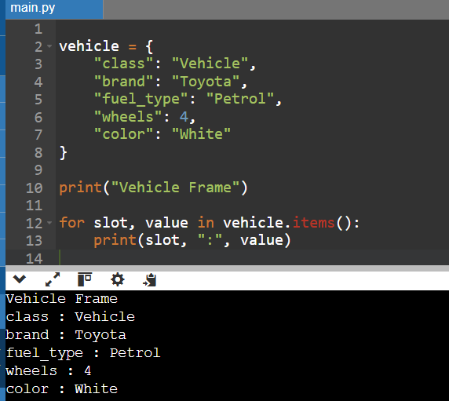
Experiment 7: Production Rules and Forward Chaining
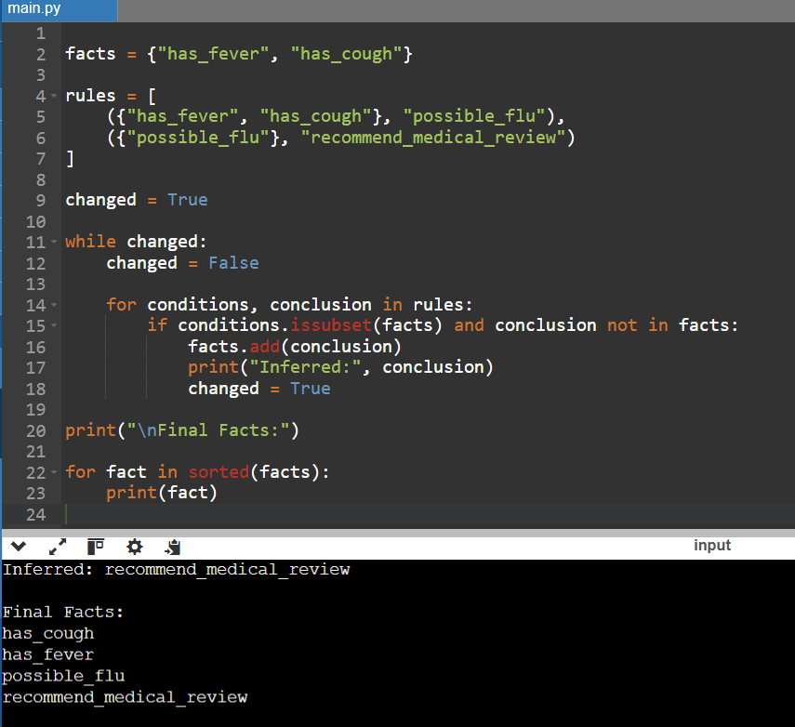

Experiment 8: Ontology Development Using Protégé
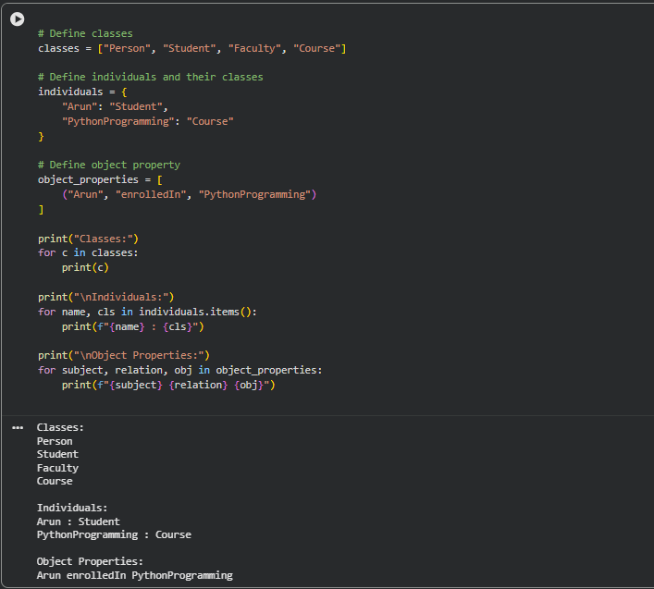

Experiment 9: Knowledge Graph Construction Using Python
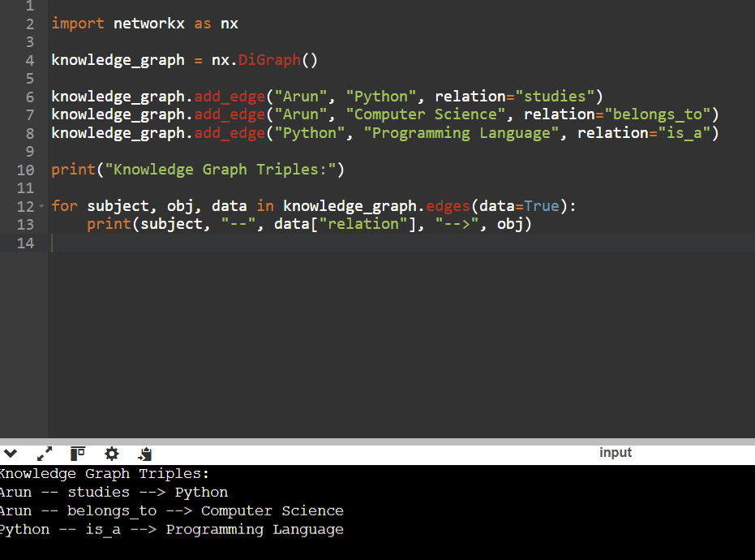

Experiment 10: Knowledge Management System
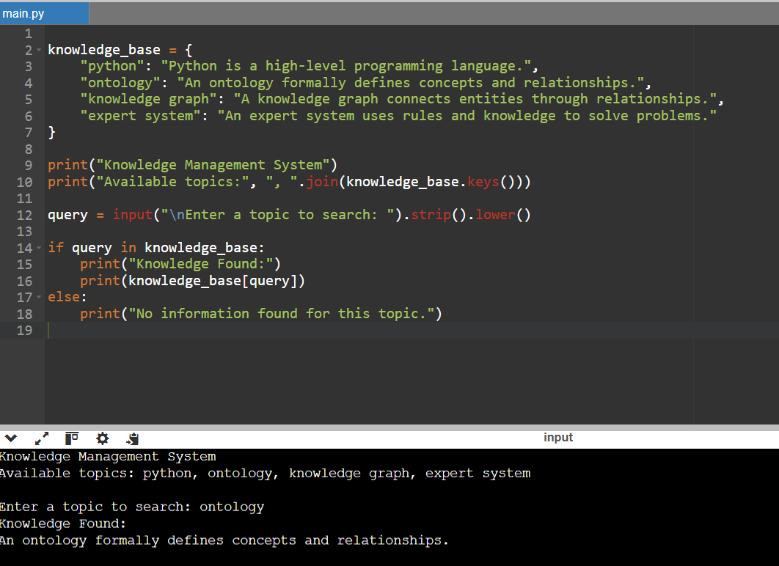

Experiment 11: RDF Knowledge Representation Using RDFLib
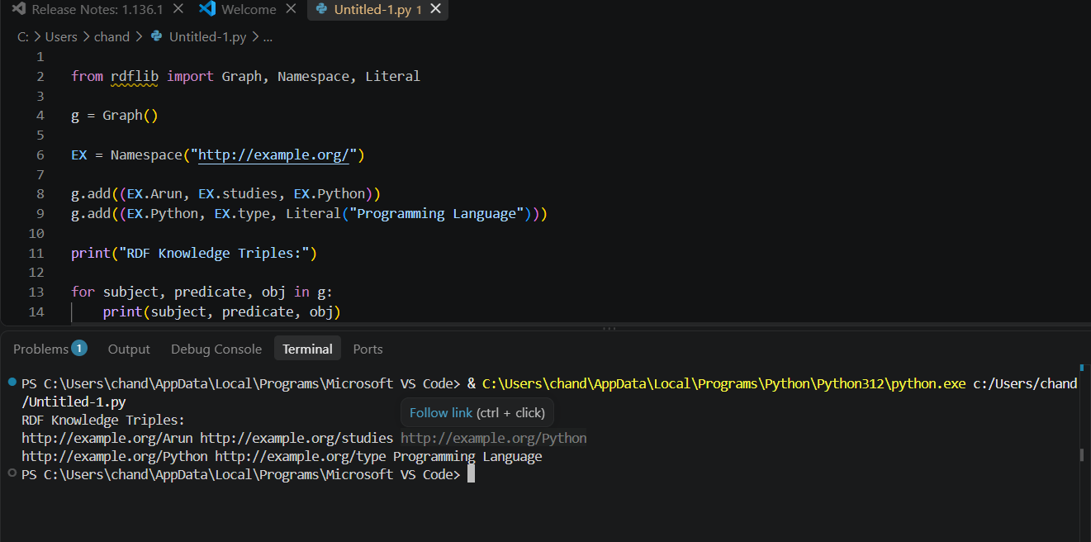

Experiment 12: Knowledge Graph Traversal Using NetworkX
